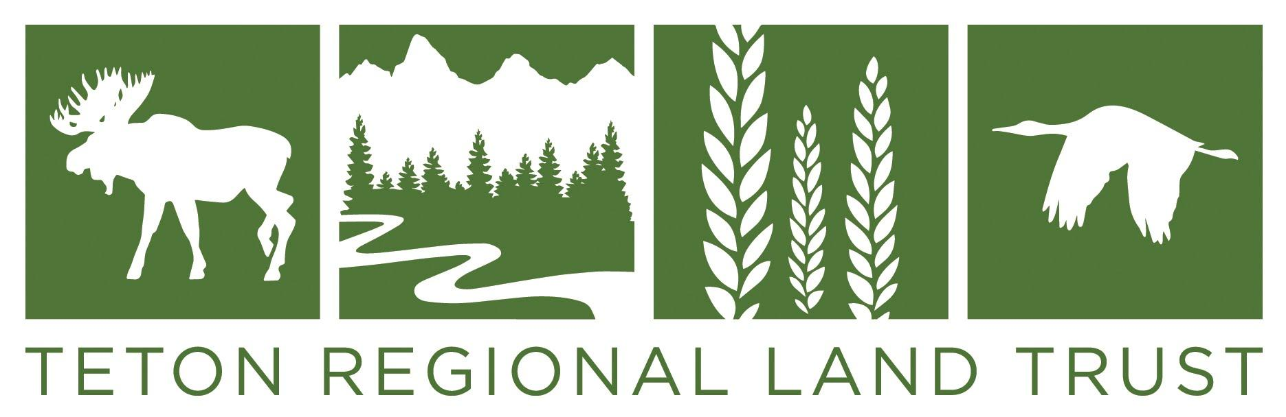

Teton Regional Land Trust, Executive Director, Driggs, Idaho
The Teton Regional Land Trust is seeking a charismatic leader. The ideal candidate has a conservation/natural resource background and is an excellent fundraiser and manager with strong skills in communication, collaboration, strategic planning, financial management, and supervision. Compensation is commensurate with experience. Please send a cover letter and resume to job@tetonlandtrust.org. Refer to www.tetonlandtrust.org for more information. Open until filled.

